Parking Efficiency Integration

CSUSB Parking

Team Members:

Ramandeep Kaur

Garrett Cuillier

James Small

David Kagawa-Aguirre

***Vision/Description***

Any student who has a class at midday can tell you that finding a parking spot can be difficult at best. What if there was a way to help increase the efficiency of the existing parking lots along with directing students to parking lots with available spots. What we are proposing is a queuing system for each parking lot that keeps track of incoming and outgoing cars and compares those numbers with the number of total parking spots for that lot. These numbers will be updated in real time and will also be displayed at each intersection that leads to a parking lot. There will also be a board at the main intersection that displays the parking statistics for every lot on campus. Utilizing a system such as this can help increase the efficiency of each parking lot while decreasing the need to construct more parking structures. The system can also be used to control the flow of traffic around the campus.

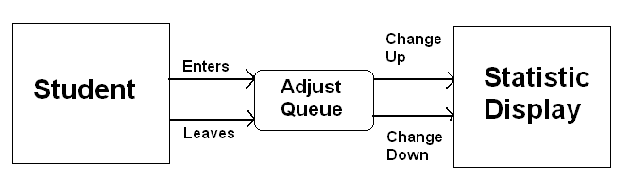

***Cost Benefit Analysis***

**Interest Rate (%): 0.06**



**Return on Investment after 5 Years(%): 41%**

**Break Even Point: 3 to 4 years**

***Lists of Costs and Benefits***

**Cost or Benefit:**  Cost of System Hardware (Includes any setup hardware, signs, sensors, etc)

**Tangible/Intangible:** Tangible

**Once/Recurring:** Once

**How Much?:** $87,000.00

**When Occurs?:** Start of Project

**Cost or Benefit:** Cost of System Programming and Setup

**Tangible/Intangible:** Tangible

**Once/Recurring:** Once

**How Much?:** $5,000.00

**When Occurs?:** Start of Project

**Cost or Benefit:** Cost of Maintenance on System Hardware

**Tangible/Intangible:** Tangible

**Once/Recurring:** Recurring

**How Much?:**  $2,500.00

**When Occurs?:** Yearly

**Cost or Benefit:** Cost of Maintenance on System Software

**Tangible/Intangible:** Tangible

**Once/Recurring:** Recurring

**How Much?:** $1,000.00

**When Occurs?:** Yearly

**Cost or Benefit:** Benefit of Students / Employees Paying $1 extra Per Quarter for Parking

**Tangible/Intangible:** Tangible

**Once/Recurring:** Recurring

**How Much?:** $12,000 (Based on 12,000 active parking permits)

**When Occurs?:** Every Quarter

**Overall Deployment Plan**

The overall deployment plan begins with the purchasing of the necessary hardware, including servers, underground sensors, and signs. Once purchased the process to installing these items begins. At the same time, the software team can begin designing the software using the api’s from the signs and sensors. This whole process shouldn’t take longer than 6 months at most. The most time used will be for the installation of the many sensors needed to cover each parking lot and structure on campus.

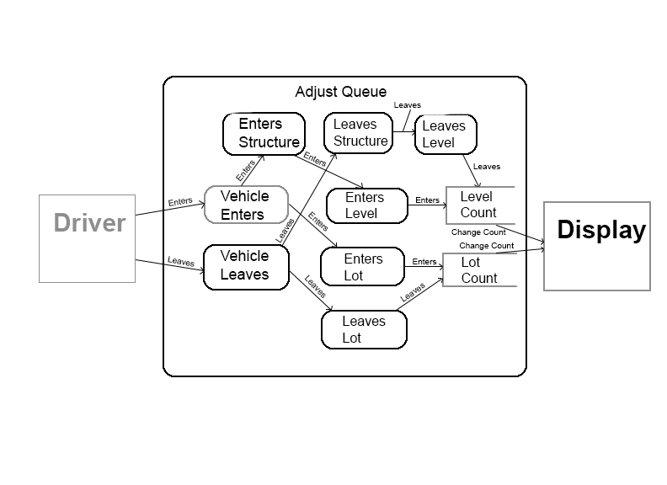

**Data Flows and Processes**

**Level 0 DFD**

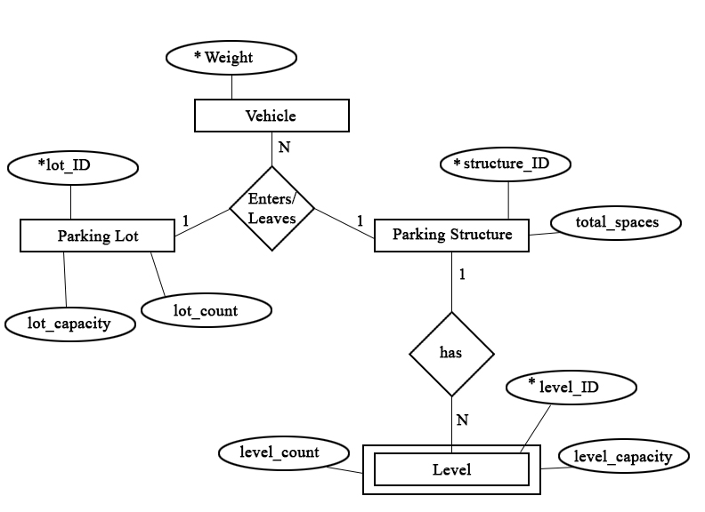

**ERD in Third Normal Form**

**Data Dictionary**

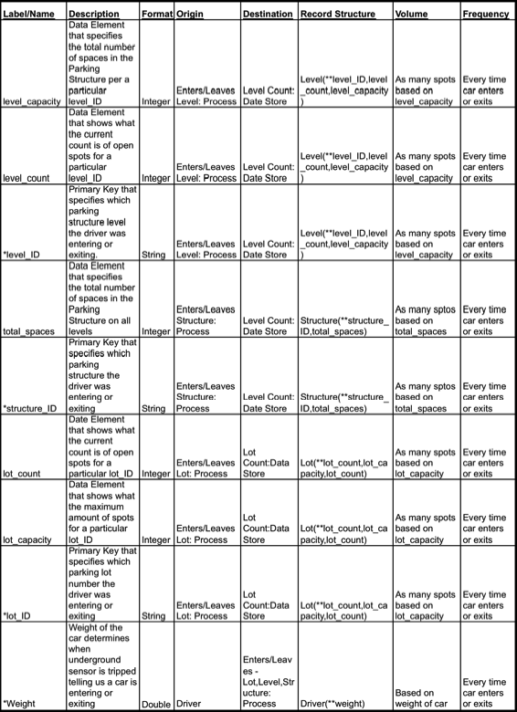

**Deployment Diagram**

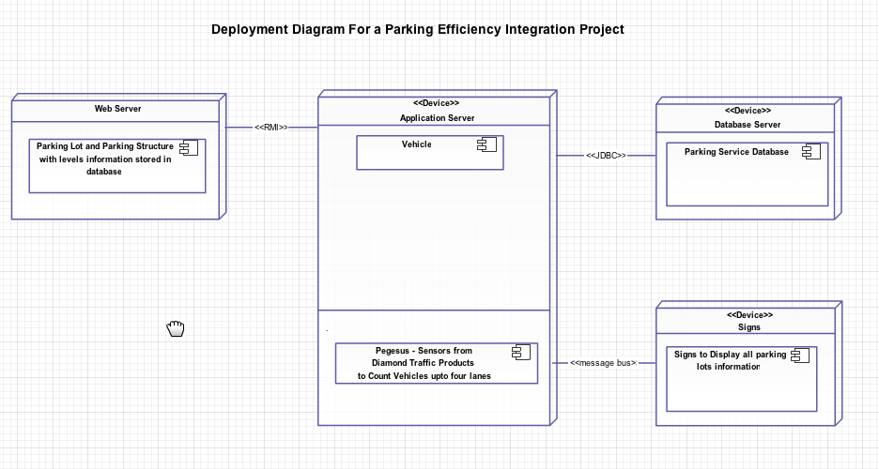

**Use Cases and Functions**

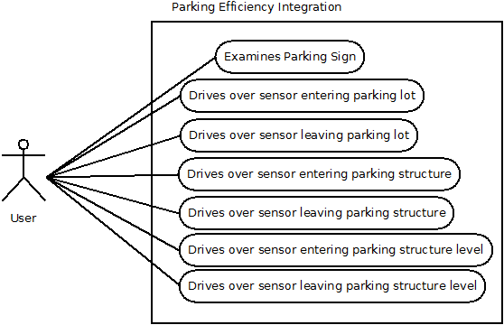

**Brief Use Cases:**

**Name:** Drives over sensor entering parking lot.

**Description:** A user drives over the parking sensor to enter the parking lot and the action is logged then reflected in the number of available spots displayed on the sign by subtracting 1 from the total.

**Name:** Drives over sensor entering leaving lot.

**Description:** A user drives over the parking sensor to leave the parking lot and the action is logged then reflected in the number of available spots displayed on the sign by adding 1 to the total.

**Fully Dressed Use Case:**

**Name:** Examines Parking Sign

**Scope:** The system in action.

**Level:** User Notification.

**Primary Actor:** User.

**Stakeholders and Interests:** User, the university.

**Preconditions:** Sign and sensors must display accurate information on the parking lot.

**Post conditions:** Sign reflects that there are spots available so the student enters lot and parks.

**Main Success Scenario:**

1: User looks at sign.

2: Sign reports that there are spots available in this parking area.

3:Student enters parking area and parks.

**Extensions:**

2a: Sign reports that there are no empty spots available.

2aa: Student does not enter parking lot.

2ab: User checks a different parking area.

2b: Sign shows parking lot full with no available spots.

2ba: User enters full lot.

2bb: Sign reflects negative number stating that parking area is overflowing.

**Special Requirements:** Parking lot has to be open.

**Frequency of occurrence:** This occurs every time a student tries to enter the parking area.

**Miscellaneous:** Could possible look into using RFID tags to specify which type (handicapped, carpool, etc) of spots are open.

**Quality Constrains:**

* Sensor will only register if certain weight is measured (>550 lbs).
* Vehicle cannot exceed specified weight in order to prevent damage (>10,000lbs).
* Sensors must be checked for maintenance every month.
* Signs must be checked for maintenance every month.

If spots are "closed" or under construction the sign must reflect new totals

**Implementation Plans**

**Plan:**

* Analysis of parking lots and structures.
* Installation of sensors at parking lot/structure entrances/exits
* Installation of signs at main entrance of CSUSB campus
* Installation of signs at parking structures
* Test all sensors

**Development Plan:**

The software and hardware is already available with Diamond Traffic Products. We would utilize their “Pegasus” traffic tally system.

**Start-up:**

Initially we would begin with the parking structures to display open slots on the individual levels. It would be easier to test the system and audit the individual levels for accuracy. After the success of the structures, we would then begin implementation on the parking lots.

**Initial Data:**

The initial data would be generated the day the hardware and software was successfully installed into the parking structure. The counter would count each level and we would audit the levels daily for the first week to ensure accuracy.

**User Training:**

The Database Administrator at Diamond Traffic Products would handle software instructions.

The current Parking Services employees would count the open spots on a given level and ensure that count matches the sign count and specific maintenance intervals.

**Operation and Maintenance Plans**

**Operation**

The operation of the system is mainly self-run. Once the initial startup values are entered for each parking lot, the system handles the rest. Every time a car enters or leaves a parking lot or structure, the system will automatically adjust the appropriate queue accordingly.

**Help/Support**

The help and support system for the system involves a simple telephone number. In any case where a person notices problems with the signs or sensors, or any other part of the system, they can alert the administrators of the problem.

**Types of Maintenance**

**Corrective Maintenance** – This type of maintenance will be performed often when any discrepancies are noticed between the number of cars in the lot and the total being displayed for that lot. Once a difference is noticed, and audit will be performed and the system will be updated accordingly.

**Adaptive Maintenance** – This type of maintenance will be performed when major problems arrive in the system. If a sensor stops working, a temporary measure will need to be put in place to keep the counts of the system accurate.

**Preventative Maintenance** – This type of maintenance will be performed on regular intervals to confirm that all of the sensors and signs are operating correctly and any replacements needed are made before a malfunction occurs.

**Periodic Maintenance** – This type of maintenance will be performed yearly during a school break so that all elements of the system, hardware and software can be tested.

**Backups**

Backups of the system are very critical for any type of system. Nightly backups of the software and data controlling the system will be done. We don’t expect much disk space to run this system, so a full nightly backup will be performed when the system isn’t being utilized as often, like in the middle of the night.